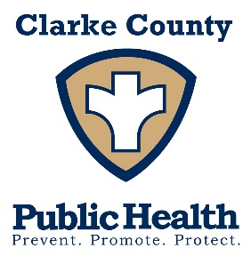
Clarke County Public Health is seeking a
Full-time Homemaker
Do you like to help others? Position available for a Public Health Homemaker to assist seniors in their home with assigned duties of cleaning, laundry, food prep and essential errands.
- Full time – 32 - 40 hours a week. Applicant must have GED/High School diploma, enjoy working with the public and have reliable transportation with proof of car insurance to travel within Clarke County as assigned.
- Applicants must be able to use computer and windows-based software systems, copier, printer, telephone, fax, and other basic office equipment.
- Benefits include mileage reimbursement, Health Insurance, FICA, and IPERS.

Applications available at Clarke County Public Health, 144 W. Jefferson in Osceola or online at www.clarkecountypublichealth.org – position open until filled.
Equal Opportunity Employer

