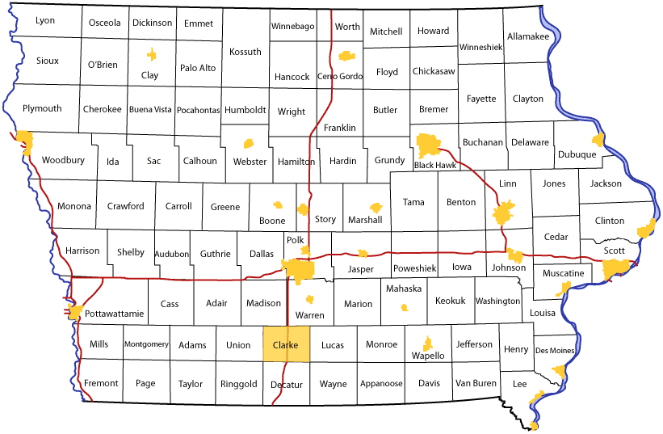

Clarke County was established on January 13, 1846. The county was named in honor of [James Clarke](http://en.wikipedia.org/wiki/James_Clarke), third Governor of Iowa Territory (www.genealogyinc.com/iowa/clarke-county). Cities located in Clarke County our Osceola, Murray, Weldon and Woodburn and the estimated population is 9,325.

In June 2015, Clarke County Public Health collaborated with Clarke County Hospital and launched an initiative to better understand the health needs of the community. This process included conducting a Community Health Needs Assessment (CHNA) to provide statistical data of the community’s health status, then taking this information and developing a Health Improvement Plan (HIP) to identify and prioritize health concerns. A collaborative approach was utilized through meetings and discussions. This report shows the findings of the CHNA and now is time to prioritize the needs of the community and decided what next area we want focus on in developing a Health Improvement Plan.

HEALTH RANKINGS FOR CLARKE COUNTY

www.countyhealthrankings.org/iowa

In 2013 *County Health Rankings* report ranked Iowa counties according to their summary measures of health outcomes and health factors. Rankings are interpreted as high ranks (e.g. 1 or 2) is healthiest and low ranks (e.g. 98, 99) least healthiest.

**The health outcomes rankings are based on an equal weighing of mortality (length of life) and morbidity (quality of life) measures.** Clarke County is ranked **87th** in State of Iowa for Health outcomes. (www.countyhealthrankings.org/iowa)

Health factor rankings are based on weighted scores of four types of factors: behavioral, clinical care, social and economic, and environmental.

* **Behaviors (30%):** Tobacco use, diet & exercise, alcohol use and sexual activities
* **Clinical care (20%):** Access to care and quality of care
* **Social and economic factors (40%):** Education, employment, income, family and social support and community safety.
* **Physical environment (10%):** Environmental quality and built environment (www.countyhealthrankings.org/iowa)
* Clarke County is ranked **91** in State of Iowa for Health factors.

A total of 422 people participated in the CHNA survey

**DEMOGRAPHICS**

Clarke County's population is 9,325 with  86.2% white, 11.5% Hispanic, 2.3% other. It was found that individuals living below poverty level in Clarke County is 13.7% compared to 12.4% in State of Iowa.  17% of adults and 6 % of children in Clarke County are un-insured. We currently have 6 healthcare providers and 3 dentists. This is considered to not be a health professional shortage area. The average life expectancy is 78.0 years (Iowa: 79 years) Clarke County's Unemployment average is 5.4 % compared to 4.7% for State of Iowa.

 

In Clarke County, 11.2 % of adults have no high school diploma.  34.2% of children 0-4 yr receive WIC nutrition services compared to 25.5% in State of Iowa. During the 2013 school year 51.5% of students were eligible for free or reduced-price lunches (40.3% Iowa) and 17.3% of Clarke County's population receive food assistance (13.6% Iowa)

**What is your connection to Clarke County?**

|  |  |
| --- | --- |
| ANSWERS: | RESPONSES: |
| I live in Clarke County | **81.66 % 325** |
| I am employed in Clarke County | **59.30 % 236** |
| I go to school in Clarke County | **3.02% 12** |
| I attend worship services in Clarke County | **28.39 % 113** |
| Total Respondents: 398 |  |

**How would you rate Clarke County as a healthy community?**

|  |  |
| --- | --- |
| **ANSWER CHOICES** | **RESPONSES** |
| **VERY HEALTHY** | **1.94% (8)** |
| **HEALTHY** | **25.49 % (105)** |
| **SOMEWHAT HEALTHY** | **60.68 % (250)** |
| **UNHEALTHY** | **10.44% (43)** |
| **VERY UNHEALTHY** | **1.46% (6)** |
| **TOTAL:** | **412 RESPONSES** |

**What makes Clarke County a good place to live, work, worship, and visit?**

1. Community 23%

* “safe community”
* “nice small town, small community”
* “it’s quiet and safe”
* “good police and fire protection”
* “good doctors and hospital, most needs are met”
* “there are many events and entertainment options, work is close to home”
* “Small town where everyone helps each other out when in need. Community that supports our small businesses.”

1. Friendly 22%

* “the friendly people”
* “the people are friendly, there are things going on”
* “people care about each other in this community”
* “The friendly people! For the most part, everyone is helpful and has a positive outlook on things that are going on and for our future!”
* “friendly people, good churches”

1. Small Town 18%

* “small town community comes together at hard times”
* “homes, jobs, entertainment”
* “small town feel, affordable, safe, friendly”
* “progressive town, close to railroad”
* “the small town atmosphere but with easy access to city amenities”

1. Good People 6%

* “The people, there are a lot of people putting in time, money and creativity to help our city grow”
* “The people in the community are very helpful, sincere and welcoming.”
* “Great people, good opportunities”
* “Friendly community, job opportunities, safe, close to a large city”

1. Good Schools 5%

* “the school is making huge strides to improve itself”
* “diverse community, good schools always looking to improve and strong development corporation”
* “quality schools”
* “It has great schools, people are very friendly”
* “Good school system including Murray and Clarke schools”

**What are some ways Clarke County could improve to make it a better place to live, work, worship and visit?**

1. Jobs 12%

* “more jobs and better salary”
* “more work opportunities”
* “raise the working wage”
* “better jobs”
* “more and better paying jobs”

1. Town 11%

* “Appearance of town, clean it up a little”
* “Maintain/upkeep all the “new projects” that get started with no long-term sustainability plan. Think with the end in mind”
* “Pride in property by property owners”
* “fix Hwy 69 through town, better curb appeal”

1. Community 11%

* “More community volunteers”
* “need more community activities”
* “I am not sure what else the county can offer that isn’t already offered? Maybe it is up to us as residents to do what we can-such as more volunteering and more community support.”
* “be friendly, keep the new people involved”
* “more community participation with other organizations”

1. Businesses 11%.

* “more business, more activities for kids”
* “need more business on main street”
* “Attract and retain more businesses. Train graduating students on hospitality and promoting Clarke County.
* “Clarke County Development Corp promoting business has been very helpful, need to continue this effort”
* “more businesses and more stores around the square”

1. Activities 9%

* “more activities for kids after school that are free or cheaper for lower income families”
* “more activities for kids and adolescents to do year round”
* “more family activities”
* “more activities in the evenings”

**What are the three most important factors for a "healthy community?" (Factors that would best improve the quality of life in a community.) Please select three options below.**

|  |  |
| --- | --- |
| **ANSWER CHOICES:** | **RESPONSES:** |
| **ACCESS TO HEALTHCARE** | **48.67 % (201)** |
| **GOOD SCHOOLS** | **44.55% (184)** |
| **GOOD JOBS AND HEALTHY ECONOMY** | **43.34% (179)** |
| **LOW CRIME/SAFE NEIGHBORHOODS** | **35.84 % (148)** |
| **GOOD PLACE TO RAISE CHILDREN** | **32.69% (135)** |
| **HEALTHY BEHAVIORS AND LIFESTYLES** | **21.79 % (90)** |
| **AFFORDABLE HOUSING** | **17.43 % (72)** |
| **RELIGIOUS AND SPIRITUAL VALUES** | **17.19 % (71)** |
| **CLEAN ENVIRONMENT** | **16.71 % (69)** |
| **STRONG FAMILY LIFE** | **14.53 % (60)** |
| **PARKS AND RECREATION** | **10.41 % (43)** |
| **AVAILABILITY OF CHILDCARE** | **5.57 % (23)** |
| **LOW LEVEL OF CHILD ABUSE** | **4.36 % (18)** |
| **ARTS AND CULTURAL EVENTS** | **3.39 % (14)** |
| **EXCELLENT RACE RELATIONS** | **3.15 % (13)** |
| **LOW DEATH AND DISEASE RATES** | **1.69 % (7)** |
| **LOW INFANT DEATHS** | **1.69 % (7)** |
| **TOTAL RESPONDENTS:** | **413** |

**What are the three most important "health issues" in our community?**

**(Behaviors that have the greatest impact on overall community health)**

**What are the three most important behaviors that negatively impact the overall health in Clarke County?**

**In your opinion, what areas need additional education in our community?**

**Are there healthcare services in Clarke County that you feel need to be added, improved and/or changed?**

* Mental Health
* Urgent Care/Walk-In clinic
* Substance Abuse
* Additional primary doctors
* OB-GYN/PEDS
* Labor and Delivery
* Medicaid services (dentists, providers that accept)
* Elderly services
* Preventative Care
* Public Health- resume more “in home” services
* Clarke County Hospital-more specialists services (Vision, Orthopedics, Diabetes, Arthritis, Pain Management, Oncology)
* Holistic health care providers
* Clarke County currently has 6 healthcare providers and 3 dentist.

**What do you mainly use as a resource for healthcare information when using the internet?**

|  |  |
| --- | --- |
| Answer choices: | Responses: |
| Online general health information | **47.84% 188** |
| Online communities and support groups | **4.83% 19** |
| Online health self-management tools | **11.20% 44** |
| Online communication with health care providers | **8.14% 32** |
| Online access to personal health records | **13.49% 53** |
| I do not use any of the above online resources | **43.51% 171** |
|  |  |
|  |  |

**Please answer the following questions. Are you:**

|  |  |  |  |  |
| --- | --- | --- | --- | --- |
|  | **YES** | **NO** | **N/A** | **TOTAL** |
| **a) Eating right (Daily5+servings-fruits/veg./wheat)** | **61.69%**  **(248)** | **36.82%**  **(148)** | **1.49%**  **(6)** | **402** |
| **b) Using tobacco products weekly** | **10.22%**  **(41)** | **80.80%**  **(324)** | **8.98%**  **(36)** | **401** |
| **c) Exercising 2-3 times weekly** | **62.59%**  **(251)** | **35.66%**  **(143)** | **1.75%**  **(7)** | **401** |
| **d) Consuming alcohol (more than 1 drink daily)** | **9.02%**  **(36)** | **85.71%**  **(342)** | **5.26%**  **(21)** | **399** |
| **e) Receiving an annual flu shot** | **72.10%**  **(292)** | **27.65%**  **(112)** | **0.25%**  **(1)** | **405** |
| **f) Scheduling yearly physicals with your primary care provider** | **72.21%**  **(291)** | **26.05%**  **(105)** | **1.74%**  **(7)** | **403** |